**An**

# **INTERNSHIP PROJECT REPORT**

# **ON**

# **WEB DEVELOPMENT**

Creating a Multipage responsive website using HTML, CSS, Java Script

By

CHALLAPALLI MANI KRISHNA SAMEERA

BRANCH: CSE(AI&ML)

ROLL NO: 207R1A6610  
 COLLEGE: CMR TECHNICAL CAMPUS  
 HYDERABAD, TELANGANA

**TABLE OF CONTENTS:**

Title

Abstract

Introduction

Existing Method

Proposed system

Implementation

Conclusion

**ABSTRACT**

Responsive web design (RWD) is a web development approach that creates dynamic changes to the appearance of a website, depending on the screen size and orientation of the device being used to view it. RWD is one approach to the problem of designing for the multitude of devices available to customers, ranging from tiny phones to huge desktop monitors.

The same HTML is served to all devices, using CSS (which determines the layout of webpage) to change the appearance of the page. Rather than creating a separate site and corresponding codebase for wide-screen monitors, desktops, laptops, tablets and phones of all sizes, a single codebase can support users with differently sized viewports.

In responsive design, page elements reshuffle as the viewport grows or shrinks. A three-column desktop design may reshuffle to two columns for a tablet and a single column for a smartphone. Responsive design relies on proportion-based grids to rearrange content and design elements.

While responsive design emerged as a way to provide equal access to information regardless of device, it is also possible to hide certain items — such as background images, as in the Transport for London example above, secondary content or supplementary navigation — on smaller screens. Decisions about hiding content and functionality or altering appearance for different device types should be based on knowledge about your users and their needs.

RWD has potential advantages over developing separate sites for different device types. The use of a single codebase can make development faster, compared to developing 3 or 4 distinct sites, and makes maintenance easier over time, as one set of code and content needs to be updated rather than 3 or 4. RWD is also relatively “future-proof” in that it can support new breakpoints needed at any time. If a 5-inch device or 15-inch device takes off in the market, the code can support the new devices. RWD doesn’t tie design to a particular device.

**INTRODUCTION**

Since official commencement of its activities in 2012, MPS (MOMENTA PHOTO STUDIO) has worked to live up to its role as an international studio by expanding partnerships with many companies around the world. First MPS was established in Bangalore Karnataka, India, by Kethika Sharma a 22-year-old brave girl, who is very passionate about photography and got degraded by the society and proved that photography is not just fun it’s more than that and she I the youngest entrepreneur in India.

MPS has since grown to encompass institutes and studios in 12 countries around the world, as well as several international studios collaborated with MPS.

MPS will continue to extend the scope of its global institutional network and build on its list of student interns and studios in order to make photography a graduate course and also hiring students from all around the globe.

MPS has worked with many popular clients like Oracle, Webex, Aprea and so on…

Momenta Photo Studio has won many awards and also set standard for photography. MPS has created many records in the very initial stages of the Career. MPS mostly works of Nature Photography and Travel Photography. There are two main photographers,

Vikram Aditya, creative head of Travel photographer and won the Best Photographer award in the year 2020. He has been nominated for the best travel photographer in the world and creative photographer in Asia.

Rahul Karthik, Creative head of Nature Photography and created history by capturing pictures of all the seasons in a single day. He has won the Best Photographer in the Asian Continent.

MPS will continue it extend its scope around the globe and will address all the issues being faced by all the photographers and students.

**EXISTING METHOD**

# There are many websites where the user can’t register for the internship they are interested in but they may find it difficult to contact the university in case of any issues and there is also no proper detailing about the each course that they offer. This is one of the major issue people are facing nowadays. In my project I’ve detailed every course and mentioned contact details as well.

PROPOSED METHOD

In the proposed method you can also apply for internship under which ever photography you want to work under. This is the unique feature which is added additionally in our website.

This helps the students to observe the conditions practically and learn from the experienced photographers. If their work is fantastic, they can be hired in to the company also.

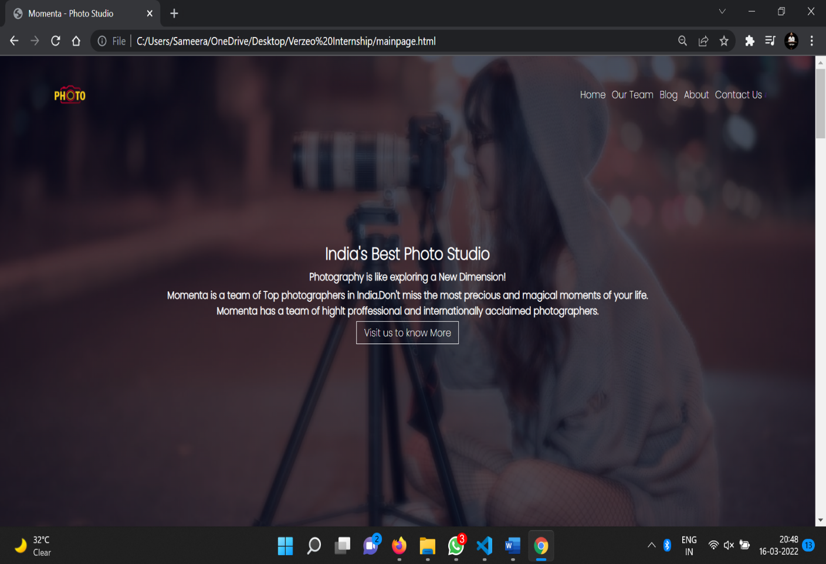

METHODOLOGY

* Creating a directory
* Gathering all the required images
* Displaying content using HTML
* Adding styles using CSS and bootstrap
* Making the website responsive using JavaScript
* Adding functionalities to every component
* Linking different web pages to the home page
* Get desired website.

IMPLEMENTATION

We use HTML, CSS, BOOTSTRAP, JAVA SCRIPT, PHP.

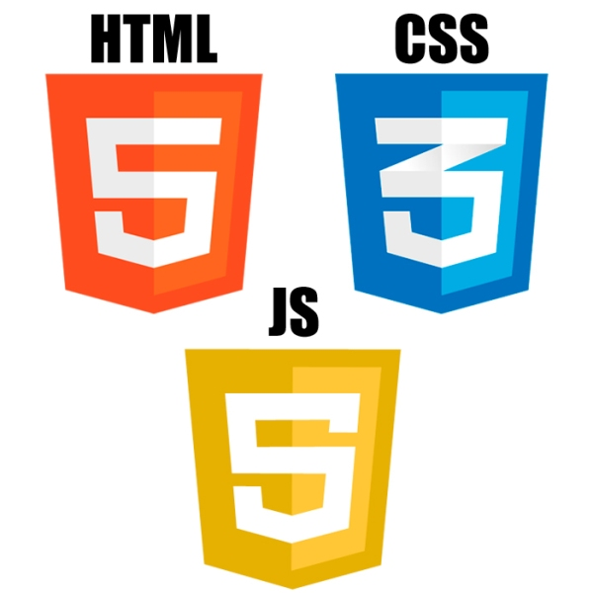

CONCLUSION

* We can make it more interactive with the user. FAQ section can be added
* Users can enrol into their desired course in a simple way and start their internship under any course.